Item #: t-1506
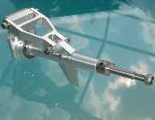
MTC Powertrimm III ECO with Fin
Drive Type:
Custom Semi-Scale Drive with Adjustable Trim and Fin to improve tracking for powerful gas engines for Catamarans and Monos
Description:
Machined from billet with large bearings. Very stiff construction for prop trim and thrust angle with authority. Built as a Swiss vault. Allows adjustment of the trim angle. The fin adds stability for boats with ridepads, stepped hulls and other high performance hulls which have little water contact. Shaft diameter is a generous 8mm and takes 1/4" flex cables. The 1/4" propshaft with drivedog accepts standard props. A security pin prevents loosing the prop and propshaft when the flex cable breaks. The flex cable is either glued in or soldered into the bore of the prop shaft. Gluing with Loctite 648 is preferred and used with the most powerful of gas engines and allows releasing the joint with a heat gun.
Application:
Large Mono hulls and Catamarans
Technical Details:
Distance transom to drivedog (leading edge of prop) | 115mm (4.5 inch)
Width: | 40 mm (1.6 inch)
Height: | 80 mm (3.2 inch)
Weight | 163g (5.7 oz)
Fin Height: | 25 mm (1 inch)
Prop Shaft | d=1/4"
Drive Shaft: | 8 mm

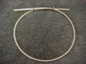  View Full-Size Image | OUT OF STOCK
 | Price: $30.00
Suhner 1/4" Welded Flex Cable (18")
Made from high quality Suhner European cable.
This is the strongest by far and best cable on the market

Product ID: rcbp1835033
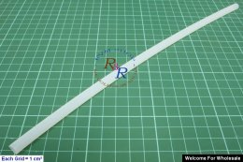
RC Boat Φ6.7mm*Φ7.7mm*300mm Flex Shaft Nylon Inner Tube
Product ID : rcbp1835033
Product Name : RC Boat Φ6.7mm*Φ7.7mm*300mm Flex Shaft Nylon Inner Tube
Specification:
Inner Diameter: 6.7mm
Outer Diameter: 7.7mm
Length: 300mm Net Weight : ~8g
Gross Weight : ~24g
Price: US$1.60
EUR€1.19 AUD$1.49 JPY¥129
Product ID: rcbp1835037
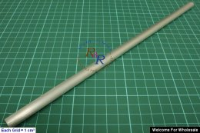
RC Boat Φ10mm*300mm Flex Shaft Aluminium Outside Tube
Product ID : rcbp1835037
Product Name : RC Boat Φ10mm*300mm Flex Shaft Aluminium Outside Tube
Specification:
Inner Diameter: 7.8mm
Outer Diameter: 10mm
Length: 300mm
Net Weight : ~20g
Gross Weight : ~45g \
Price: US$2.67
EUR€1.99 AUD$2.49 JPY¥215

Flex Safety incl. support bearing 1/4'' (2256)
The 7mm intercept bearing avoids vibrations of the 1/4'' flexshaft and also serves as thrust washer for flex safety.
Suitable for brass/ teflon pipe 10mm and flexshaft 1/4''.
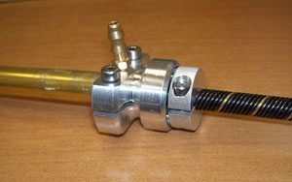 24.00 €

